
C PROGRAMMING ASSIGNMENT
Student Submission Template
Student Name | S.Niranjana
Register Number | 1925260218
Course Code & Name | CSA0210 - C Programming
Slot | C
Assignment / Task Title | Electricity Billing System  Select Suitable Data Types and Analyse Overflow  Task -  T
GitHub Repository URL
Submission Date
Instructions to Students
1. 2. 3. 4. 5. | Complete every section for each assigned task.  Write your own explanation, algorithm/pseudocode, and program.  Run the program and insert a clear screenshot of the output. Include test cases and a short analysis where applicable.  If code is maintained on GitHub, provide the correct repository link.

TASK 1 — Understand the Problem and Identify the Data
Task / Problem Statement
The aim is to analyse an electricity billing problem and identify the data required to calculate the electricity bill. The program should calculate units consumed, energy charges, fixed charges, and the total bill.
Aim
To identify the inputs, outputs, constants, variables, and validation rules required for an electricity billing program.
Concept / Theory
An electricity billing program uses input values and mathematical calculations to find the total bill. The previous reading is subtracted from the current reading to calculate the units consumed.

Inputs include previous reading, current reading, household number, and category. Outputs include units consumed, energy charge, fixed charge, and total bill.
Procedure / Algorithm
1.Identify the inputs required for electricity billing.
2.Identify the outputs to be calculated.
3.Separate constants from variables.
4.Check the inputs for invalid or negative values.
5.Calculate the units consumed and electricity bill.
Program / Source Code
#include <stdio.h>
int main()
{
int previous, current, units;

printf("Enter previous reading: ");
scanf("%d", &previous);

printf("Enter current reading: ");
scanf("%d", &current);

if (previous < 0 || current < 0 ||
current < previous) {
printf("Invalid meter reading\n");
} else
{
units = current - previous;
printf("Units consumed = %d\n", units);
}
return 0;
}
Output Screenshot

- 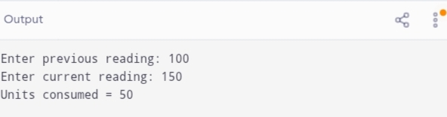Analysis / Discussion
- Inputs are previous reading, current reading, household number, and category.
- Outputs are units consumed, energy charge, fixed charge, and total bill.
- Tariff rates should be stored as constants.
- Meter readings should not be negative.
- Decimal values may be required for electricity charges.
- Integer readings are easy to calculate and compare.
- String readings require conversion before numerical calculations.
- Reading conversion and comparison take O(d) time for d digits.
- Suitable data types help handle large values and avoid overflow.
Result
The electricity billing problem was analysed successfully. The required inputs, outputs, constants, variables, and validation rules were identified.

TASK 2 — Select Suitable Data Types and Analyse Overflow
Task / Problem Statement
The task is to select suitable C data types for electricity billing and analyse integer overflow, floating-point errors, and meter rollover.
Aim
To choose appropriate data types for storing meter readings and charges and understand the errors that may occur during calculations.
Concept / Theory
C provides different data types for storing different kinds of values.
int stores integer values.
- long long stores larger integer values.
- float stores decimal values with limited precision.
- double stores decimal values with greater precision than float.
- char stores a single character.
Integer overflow occurs when a value exceeds the range supported by its data type. Floating-point calculations may produce small precision errors.
Meter rollover occurs when a meter reading returns to zero after reaching its maximum value.
Procedure / Algorithm
1.Identify the values to be stored.
2.Select suitable data types for the readings and charges.
3.Get the previous and current meter readings.
4.Check whether the readings are valid.
5.Calculate the units consumed and display the result.
Program / Source Code
#include <stdio.h>
int main()
{
long long previous, current, units;

printf("Enter previous reading: ");
scanf("%lld", &previous);

printf("Enter current reading: ");
scanf("%lld", &current);

if (previous < 0 || current < 0 ||
current < previous) {
printf("Invalid reading or rollover detected\n");
} else
{
units = current - previous;
printf("Units consumed = %lld\n", units)
}
return 0;
}
Output Screenshot

- 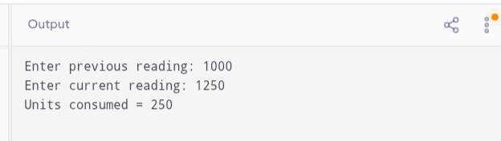Analysis / Discussion
- long long is suitable for large integer meter readings.
- double is suitable for electricity charges containing decimal values.
- Integer overflow can produce incorrect results if the value exceeds the supported range.
- Floating-point calculations may have small precision errors.
- For a meter with a known rollover modulus M, rollover units can be calculated as (M - previous) + current, provided exactly one rollover occurred.
- A reading lower than the previous reading may indicate rollover or invalid data.
- Additional meter information is required to distinguish rollover from an incorrect reading.
Result
Suitable data types were selected, and integer overflow, floating-point precision, and meter rollover were analysed.
TASK 3 — Define Tariff Constants and Calculate the Electricity Bill
Task / Problem Statement
The task is to define tariff rates and billing limits as constants and use them to calculate electricity charges. It also involves understanding the differences between #define, const, and enum in C.
Aim
To use constants in an electricity billing program and understand how they improve readability, maintainability, and calculation accuracy.
Concept / Theory
Constants represent fixed values that should not change during program execution.
- #define defines a macro that the preprocessor replaces before compilation.
- const declares an object that cannot be modified through that identifier.
- enum defines named integer constants.
Using meaningful names for tariff rates makes the program easier to read and update.
Procedure / Algorithm
1.Define the tariff rates as constants.
2.Get the electricity units consumed.
3.Validate the input.
4.Calculate the energy charge using the applicable tariff slabs.
5.Display the calculated electricity charge.
Program / Source Code
#include <stdio.h>
#define RATE1 1.50
#define RATE2 2.30
#define RATE3 3.00
int main()
{
int units;
double charge;

printf("Enter units consumed: ");
scanf("%d", &units);

if (units < 0) {
printf("Invalid units\n");
}
else if (units <= 100) {
charge = units * RATE1;
printf("Energy charge = Rs. %.2f\n", charge);
}
else if (units <= 300) {
charge = 100 * RATE1
+ (units - 100) * RATE2;

printf("Energy charge = Rs. %.2f\n", charge);
}
else {
charge = 100 * RATE1
+ 200 * RATE2
+ (units - 300) * RATE3;

printf("Energy charge = Rs. %.2f\n", charge);
}
return 0;
}
Output Screenshot
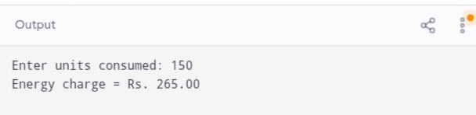

Analysis / Discussion
- #define performs text replacement before compilation.
- const provides type checking and follows normal C scope rules.
- enum is useful for named integer values, such as household category codes.
- Meaningful constant names improve readability.
- Updating a tariff constant makes the program easier to maintain.
- Incorrect tariff values can produce incorrect bills.
- The example calculates only the energy charge. A fixed charge must be added separately if required by the billing rules.
Result
Tariff constants were defined and used to calculate electricity charges. The differences between #define, const, and enum were studied.

Test Cases / Validation Table

Record different inputs, expected results, actual results, and whether each test passed.
Test No. | Input / Scenario | Expected Output | Actual Output | Status
1
2
3
4
5
Final Submission Checklist
☐Student and course details completed
☐Task statement, aim, theory, and algorithm included
☐Program code is readable and runs successfully
☐Output screenshot included
☐Analysis and result written in own words
☐Test cases completed where applicable
☐GitHub repository link added if required
Python Programming Assignment — Student Template

